**CAR RENTAL SYSTEM C++**

### Project Report

### *Submitted in the partial fulfillment for the award of the degree of*

# BACHELOR OF ENGINEERING

### IN

### Information Security CSE

### ________________

### Submitted by:

### Prakash Singh

### 20BCS3707

### _______________

### Under the Supervision of:

### GURPREET SINGH PANESAR

### Text Description automatically generatedProfessor

# DEPARTMENT OF COMPUTER SCIENCE AND ENGINEERING APEX INSTITUE OF TECHNOLOGY

### CHANDIGARH UNIVERSITY, GHARUAN, MOHALI - 140413,

**PUNJAB**

**July - 2021**

**DECLARATION**

I, **Prakash Singh**, student of **‘Bachelor of Engineering in information security**, **session: 2020-2024**, Department of Computer Science and Engineering, Apex Institute of Technology, Chandigarh University, Punjab, hereby declare that the work presented in this Project Work entitled ‘ **Car Rental System’** is the outcome of our own bona fide work and is correct to the best of our knowledge and this work has been undertaken taking care of Engineering Ethics. It contains no material previously published or written by another person nor material which has been accepted for the award of any other degree or diploma of the university or other institute of higher learning, except where due acknowledgment has been made in the text.

<Font size 14><Regular><Justified>

#### Date:25 JULY 2021

**Place: CHANDIGARH**

### Prakash Singh ( 20BCS3707)

**Abstract of the Project**

Car rental System is an online service that can be setup for renting cars to customers which help in managing payments, customer management etc.

* It's simple and effective
* Manage customers in an easy way
* Keep track of payments
* Data can be updated, deleted and created easily.
* It is secure as admin can login only by using password.
* No need for a high-level system for program.
* Changes can be done as per requirements.

**Acknowledgement**

On this great occasion of accomplishment of our project on ‘**Car Rental System’**,

We would like to sincerely express our gratitude to **Mr. Gurpreet Singh Panesar**, who has been supported through the completion of this project.

We would also be thankful to Assistant Professor **Mrs. Akwinder Kaur** of **Chandigarh University** for providing all the required facilities in completion of this project.

We would like to thank our friends who helped us in the completion of this project without whom this project could not be completed in time. Finally, as one of the team members, I would like to appreciate all my group members for their support and coordination, I hope we will achieve more in our future endeavors

Prakash Singh

20BCS3707

|  |  |  |
| --- | --- | --- |
| NAME | UID | CONTIBUTION |
| SUSHANT | 20BCS3708 | IN CODE /REPORT/PPT |
| PRAKASH SINGH | 20BCS3707 | IN CODE/REPORT/PPT |
| ABHINAV TOMAR | 20BCS3698 | IN CODE/REPORT/PPT |

**Table of Contents**

* Title Page
* Declaration of the Student
* Abstract
* Acknowledgement
* List of Figures
* List of Tables (optional)
* Timeline / Gantt Chart
* **INTRODUCTION\***

* Problem Definition
* Project Overview/Specifications
* Specifications
* **PROJECT SURVEY**
* Existing System
* Proposed System
* Feasibility Study
* **PROBLEM FORMULATION**
* **OBJECTIVES**
* **METHODOLOGY**
* **CONCLUSIONS AND DISCUSSION**
* **REFERENCES**

**INTRODUCTION**

This project is designed so as to be used by Car Rental Company

specializing in renting cars to customers. It is a system through

which customers can view available cars, register, view profile

book car. The advancement in Information Technology and internet

penetration has greatly enhanced various business processes and

communication between companies (services provider) and their

customers of which car rental industry is not left out.

It automates manual procedure in an effective and efficient way. This automated system

facilitates customer and provides to fill up the details according to their requirements. It includes

type of vehicle they are trying to hire and location. The purpose of this system is to develop a

web site for the people who can book their vehicles along with requirements from any part of the world

**Benefits of Online Car Rental Services-**

* This online car rental solution is fully functional and flexible.
* It is very easy to use.
* This online car rental system helps in back office administration by streamlining and standardizing the procedures.
* It saves a lot of time, money and labour.
* Eco-friendly: The monitoring of the vehicle activity and the overall business becomes easy and includes the least of paper work.
* The portal acts as an office that is open 24/7.
* It increases the efficiency of the management at offering quality services to the customers.
* It provides custom features development and support with the software

**PROJECT SURVEY**

**EXISTING SYSTEM-**

* The details regarding customers were manually written and recorded. There was no system of paying fees online. The customers were not notified regarding the fee payments that were outstandings.
* Also the existing system is time taking and not efficient.
* Files are used in existing systems which occupy lots of space and maintenance of files is not easy and data may be lost sometimes

**Proposed System-**

* Our Project is a c ++ program which is made by using different classes, objects and functions to manage the whole system in an easy and effective way.
* Our car rental system provides lots of functions such as data entry of customers, keeping records of all the things about customer’s fees, and plans which help to provide good quality of services to customers.

**Project Feasibility-**

**Technical Feasibility –**

* Project is based on C++ program which uses various concepts as Oops, file handling and some more C++ features. The program includes classes, objects and various functions which are named as per their use in the project and manage the whole program in an effective manner.
* Program includes various functions to fulfil the user requirements so it’s easy to change it in future according to the requirements of users.
* It is solving various problems which arise due to the existing system
* No high-level software or hardware requirements as the program can be run on a system having an editor as vs code compiler.

**So on the basis of the above points it can be concluded that Project is technically feasible.**

**Economical Feasibility –**

* In the existing system there was use of files which are costly as well as after some time files may be destroyed due to various reasons so, cost of maintenance was high.
* Our Project can be used on a computer directly and doesn't need to spend on maintenance, also no extra funds are required to make the project and in future further development can be done easily without extra expenditure, so it is economically feasible also

**PROBLEM FORMULATION**

* The details regarding customers were manually written and recorded. There was no system of paying fees online. The customers were not notified regarding the fee payments that were outstanding.
* Also, the existing system is time taking and not efficient. In the existing system data retrieval is not easy and it is a waste of time when manually searching for data
* Files are used in existing systems which occupy lots of space and
* Feasible so that it can be transformed according to the need Some slight changes in that program

**OBJECTIVES**

* The main objective of the project is to develop software that facilitates the data storage, data maintenance and its renting car in an igneous way.
* To store the record of the customers, the staff that has the privileges to access, modify and delete any record and finally the service provides to its customers.
* Also, only the staff has the privilege to access any database and make the required changes done by login using a specific password, if necessary.
* To develop a user friendly system that requires minimal user training.
* Speeding up operations
* To centralize the management of the system
* Reduce data loss in the manual system already in place.
* Reduce the cost of maintenance of the garage and data storage and reduce the space occupied by the files being used.
* Main objective of the project is to automate the whole management system inside car renting garages

**METHODOLOGY:-**

**UML CASE DIAGRAM**

* Verify password*

CUSTOMER

Login add car

Book car remove car

Reschedule Display all cars

Cancel booking modify car

Review booking account

Create account block

Delete account

*admin*

Modify deails

***Flow Chart of Structure of Project***

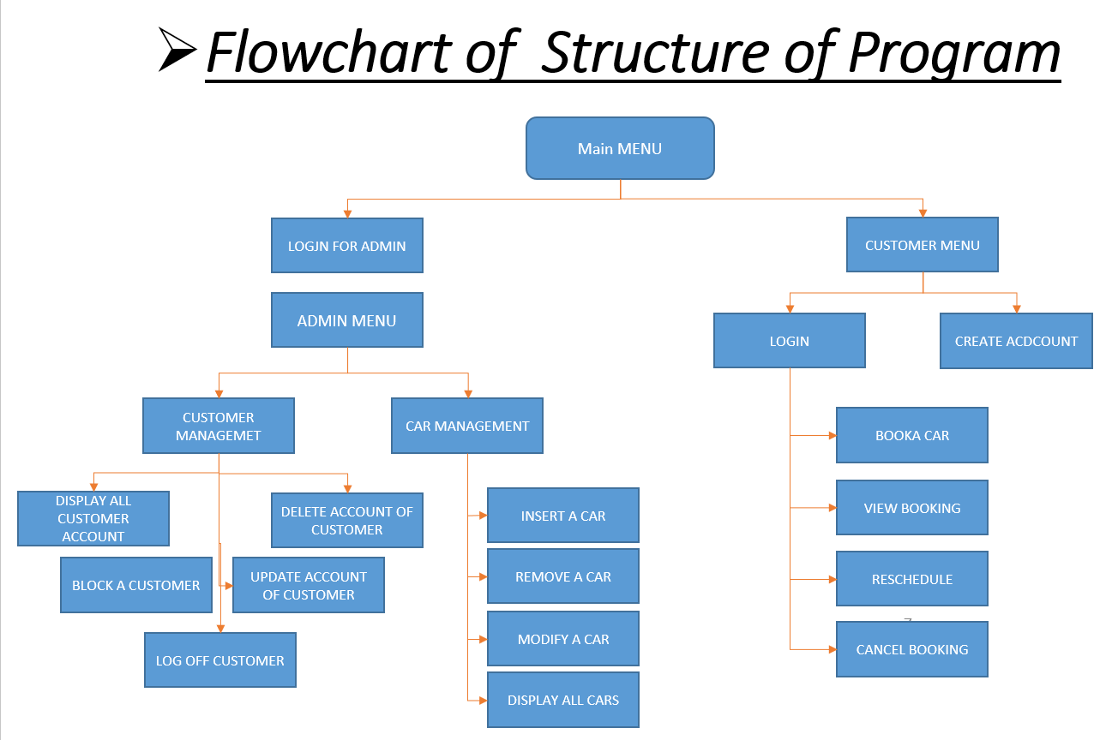

**CONCLUSION AND DISCUSSIONS**

Our project is only a humble venture to satisfy the needs to manage their project work. Several user friendly coding has also been adopted. The objective of the software planning is to provide a framework with a limited project completion time frame at the beginning of the project and should be updated on a regular basis.

**POSSIBLE FUTURE WORK**

• We can give more advance software for online car rental systems and add more facilities.

• We can add printer in the future.

• Integrate multiple load balancers to distribute the load of system.

• Create a backup mechanism for backing up data and informations.

• We will host the platform on online servers,to make it accessible worldwide.

• Today, the market place is flooded with several car rental options for shoppers to choose from.

• A variety of innovative products and services are being offered spoiling customers for choice. Online car rental system is no more a privilege enjoyed by your friends and family.

**REFERENCES**

# [www.google.com](http://www.google.com)

# <https://doc.qt.io/qt.html>

[**https://youtu.be/3nQzoLtClUY**](https://youtu.be/3nQzoLtClUY)

[**https://youtu.be/MPJT9xwIBUI**](https://youtu.be/MPJT9xwIBUI)